David L. Suddjian
Biological Consulting Services

801 Monterey Avenue, Capitola, CA 95010
Telephone 831· 479· 9603, email dsuddjian@aol.com

Summary of 2006
Corvid Monitoring Surveys

In The Santa Cruz Mountains

Prepared for

Command Oil Spill Trustee Council

Prepared by

David L. Suddjian
Biological Consulting Services
801 Monterey Ave., Capitola, CA 95010

February, 2008
Final Report

INTRODUCTION

In 2002 David Suddjian (unpubl. data) conducted a pilot study in Big Basin Redwoods State Park, Portola Redwoods State Park, Butano State Park, and San Mateo County Memorial Park (Figure 1) to compare relative abundance of corvids in areas of high human use with those well removed from areas of high use. In 2003 the Command Oil Spill Trustee Council (COSTC) initiated a corvid monitoring program in the same four parks that was patterned closely the 2002 effort (Suddjian 2004). The COSTC study was to assist the Council in restoration planning for potential projects benefiting the Marbled Murrelet (Brachyramphus marmoratus), including corvid management. This report presents the results of corvid monitoring surveys conducted in 2006.

Corvids are among the most significant predators on eggs and chicks of marbled murrelets (Nelson 1997, Peery et al. 2004). Both Steller’s Jay (Cyanocitta stelleri) and Common Raven (Corvus corax) have been documented to prey on murrelet eggs or chicks in the Santa Cruz Mountains (Singer et al. 1991, Suddjian 2003, 2003b, Perry et al. 2004), and Peery et al. (2004) demonstrated rates of nest predation as high as 61-87% in the region.

The Steller’s Jay has apparently always been a prominent member of the avian community in old growth forests of the Santa Cruz Mountains. In contrast, Common Ravens are relatively new in those forests, and have only become numerous since the 1980s (Figures 2 and3; Kelly et al. 2002, Bousman 2007). Both species are attracted to campgrounds and other areas of parks with high human use, where human food is often readily available. Consequently, previous studies and general observations in the Santa Cruz Mountains have typically found both Steller’s Jay and Common Raven to be much more numerous at campgrounds than away from campgrounds. A third species of corvid, American Crow (C. brachyrhynchos), has been recorded only once in the areas encompassed by this study (one shot at Huckleberry Campground at Big Basin on April 6, 2005; P. Halbert pers. comm.). This remains the only record from the interior part of Big Basin Redwoods State Park (they are rare non-breeding visitors coastward at the park’s Rancho Del Oso unit), and crows do not yet occur at the other three parks.

This study compares corvid populations in murrelet nesting habitat within campgrounds (treatment areas) to corvid populations in such habitat in areas located >300 meters from campgrounds (control areas). It also provides a baseline from which to judge future changes in numbers related to corvid management projects in the parks. Such projects were initiated in 2005.

Methods

Study Design

The 2002 pilot study sampled corvids in nine treatment areas and 19 control areas within the four parks and on adjacent private forest land (D. Suddjian unpubl. data). The monitoring program initiated by COSTC in 2003 established and surveyed one or more treatment and control areas in each park in 2003, except at Memorial, where no suitable control areas were identified (Table 1, and Figures 3-6). All of the treatment and control areas selected for the COSTC study overlapped entirely or partially with areas surveyed by Suddjian in 2002. Surveys in 2003 to 2006 sampled seven treatment areas and 12 control areas. All survey areas are in coast redwood (Sequoia sempervirens) forest known to support use by Marbled Murrelets, with nesting known or suspected to occur either in or immediately adjacent to each survey area. They range in size from 3.2 to 15.7 hectares (Table 1). In 2005 and 2006 trees with potentially suitable nest platforms (Pacific Seabird Group 2003) were counted in each survey area to provide a measure of the habitat quality of each site for murrelets (Table 2).

Control areas are located a minimum of 300 meters from any campground, picnic area, or residential community, and are located along roads or trails to facilitate access. Treatment areas include standard campgrounds and their immediate surroundings. Group campgrounds were excluded because they were irregularly occupied, and they were often smaller than a minimum size criterion of 3.0 hectares (Suddjian 2004).

Management projects were initiated in 2005 in the three state parks to affect corvid populations. These included direct removal of ravens, increased emphasis on proper food storage, increased education about Marbled Murrelets and about corvids as predators, and warnings and citations for campers feeding wildlife or improperly storing food or trash. These actions continued in 2006, now including Memorial County Park in efforts to educate park users through use of signage in and near campgrounds.

Description of Survey Areas

General Patterns Of Human Use

The campgrounds are used continuously throughout the survey period of June to August, although occupancy varies daily and throughout the season. Occupancy is typically at or near 100% on weekends, but often considerably less on weekdays, and is greater in July and August than in June. Campground occupancy during the surveys in 2006 ranged from 7% to 100% (Table 3). Average occupancy for each campground in 2006 did not differ much for most sites compared to 2005, except it was down by 15% at Sequoia Flat in Memorial County Park (Table 3). Overall, average campground occupancy for all site combined during the corvid surveys was very close to 2005, but occupancy declined over the four year period of 2003-2006 (r2=0.899, P = 0.026).

Human foods are continually available to corvids in varying degrees at occupied campgrounds. Food is occasionally (but regularly) offered directly to wildlife by campers, but is also widely available as discarded or fallen scraps or fragments, garbage left at camp sites, food fragments stuck on grills at fire rings, and at water spigots where dishes are rinsed. Food left unattended during the day or improperly stored at night is commonly plundered by wildlife. Additionally, in some parks food is readily available at trash receptacles that permit animal access, spillage by animals, are left open, or are too full to close properly. Another human-related food source, although more rarely available than human food, was road killed mammals, such as squirrels, raccoons and skunks.

Human activity in the control areas is mostly limited to hiking, bike riding and jogging, with no established picnic sites. Although each control area receives daily use by people in June to August, no one other than the surveyor were evident during any of the morning surveys in control areas in 2003 to 2006, with the exception of one park maintenance vehicle that drove through once at one site in 2005, and one jogger at one site in 2006.

Big Basin Redwoods State Park

Treatment areas are Blooms Creek Campground (55 sites), Sempervirens Campground (31 sites), Huckleberry Campground (71 sites), and Wastahi Campground (27 sites) (Table 1, Figure 4). Two control areas are located along the upper reach of Opal Creek, and four are along Gazos Creek Escape Road west of Opal Creek (Table 1, Figure 4).

Campgrounds had trash dumpsters with plastic lids, and a small number of metal trashcans with hinged wooden lids. The margins of the plastic and wooden lids on most dumpsters were chewed by squirrels, enabling them to enter and scavenge, occasionally dragging trash and food out of the dumpster. Rusted holes in some dumpsters permitted the same access to garbage. The lids on the dumpsters and trashcans were usually closed, but rarely were left open, and occasionally (following weekends) the lid of an overly full dumpster could not be closed, permitting birds and other animals to reach its contents.

Portola Redwoods State Park

The treatment area is the main campground, referred to here as Portola Campground (53 sites; Table 1, Figure 5). The control areas are along Peters Creek north of the campground, and in two areas along the Iverson Trail (Table 1, Figure 5).

The campgrounds and picnic areas at Portola have metal trashcans with animal proof lids. Rarely overfull trashcans had garbage spilled outside, but usually there was no spillage observed around the garbage receptacles in Portola, and none was evident during visits in 2006.

Butano State Park

The treatment area is the Ben Ries Campground (38 sites; Table 1, Figure 6). The control areas are along the Butano Service Road extending northeast from the campground, Goat Hill Trial, and Doe Ridge Trail (Table 1, Figure 6).

In 2006 Ben Ries Campground had new animal-proof metal trashcans, replacing the older receptacles that had wooden lids. No animal access to the cans or spillage around the cans was observed in 2006.

San Mateo Memorial County Park

The treatment area is the Sequoia Flat Campground (104 sites) (Table 1, Figure 7). No control areas with suitable habitat and sufficient distance from areas of high human use were identified, so control areas for this park were located in Big Basin instead (four areas along Gazos Creek Escape Road, Figure 4).

Sequoia Flat campground had 35 open metal trash cans with no lids, and one small metal dumpster with a plastic lid. Animal access was commonly observed. Trashcans were routinely tipped over and spilled by raccoons and other mammals, and mammals entered the cans and carried garbage out of them onto the ground.

In 2003-2005 it was observed that park staff traveled through the campground in the morning to empty the cans. In 2006 park staff visited the campground to empty cans in the evening, but not all cans were emptied each time, so food and garbage still remained, or was added to the cans by campers later in the evening. On the whole, the amount of garbage available to nocturnal animals (which cause most of the spillage) was reduced with the new regime, with corresponding reductions in availability for corvids. However, trash was still readily available due to the lack of lids and continued spillage.

CoRvid Survey Methods

Each site was surveyed using the total area search method (Ralph et al. 1993). The search area at treatment areas included the entire area of campsites and extended outward 50 meters from the edge of the camp boundary. Control areas were established along roads and trails, and the search area extended outward for 50 meters from the center of the road or trail. Thus, the control areas were equivalent to 100-meter wide strip transects in which the total area searches were conducted. Fifty meters was selected as the outside distance to insure the best chance of visual detection of perched, silent birds. Vegetation obscured views too significantly beyond 50 meters. Movement off the road or trail was avoided in control areas to minimize noise made by the surveyor.

David Suddjian conducted all the surveys. Surveys were done by walking slowly through the survey site and pausing often for brief periods, listening for vocalizations and making visual scans to detect corvids. Although Luginbuhl et al. (2001) found that broadcasting taped calls enhanced detections of ravens, this method was not used in this study to avoid disturbance of campers and distraction to the surveyor when campers would inquire about the broadcast calls. Furthermore, the taped calls might attract ravens into the survey areas from outside the boundary during the survey.

Each jay and raven was recorded, indicating its age if known. Aging of ravens was straightforward through the season due to the status of molt of adults, feather wear, vocalizations, and the presence of a pale gape on the juveniles. Aging of jays was easy in June and most of July (using plumage pattern, begging behavior and vocalizations, and the pale gape of the juveniles), but it became more difficult in late July and August, when the juveniles more closely resembled adults and begging activity declined. Aging silent jays was sometimes difficult due to poor lighting conditions. Behavior of jays and ravens was recorded in notes, particularly as it related to foraging.

Other information recorded for each survey included date, start and end times, weather conditions, number of occupied campsites, number of opportunities to access human food (i.e., spilled trash, unattended food, campers feeding wildlife), and details of foods consumed by corvids.

Survey Frequency and Timing

Four surveys were conducted at each site, with one survey in June, two in July, and one in August. Survey dates in 2006 for each site are given on Table 4. Each site was surveyed only once per day (or if surveyed more than once per day, then data from the first survey of the day was used for analyses here), but usually more than one site was surveyed on the same morning. Campgrounds were only surveyed on weekdays. An effort was made to sample each site on dates close to those when it was sampled in prior years.

Each survey occurred in a window beginning 35 minutes after sunrise and extending for up to four hours after sunrise. The rationale for selection of this window of time for the surveys was described in Suddjian (2004). The time required to cover each survey area varied with the size of the area, but the average rate of coverage was 3.1 minute per ha (± 0.6 minute). The time expended in each area was kept fairly consistent over each of the four replications, and each year.

Analyses

Analyses comparing treatment and control areas used only the maximum number of corvids detected on any of the four surveys of each area (Luginbuhl et al. 2001), although average counts are also presented in the tables. No effort was made to distinguish among ages of corvids for these analyses. Values of p < 0.05 were considered statistically significant, while values 0.1> p > 0.5 were considered marginally significant.

Some comparisons are made to the results of the preliminary study of 2002 (D. Suddjian unpubl. data) for all sites pooled together, as the sites were either the same as those of the COSTC-sponsored surveys, or overlapped with them broadly, and the surveys methods were the same.

Results

Steller’s Jay

Survey results and statistical comparisons for each park in 2006 are given on Tables 5 and 6. Raw counts for 2003 to 2006 are given in Appendix 1. Steller’s Jays were recorded at all survey sites, except for the control area “Opal 3” in Big Basin. They were recorded on all surveys in treatment areas, and on 85% of 48 surveys in control areas (Table 5). They were ubiquitous in treatment areas, where overall they were 9.0 times more numerous than in control areas, with the difference being highly significant (Table 6). The higher numbers in treatment areas compared to controls was significant for each park, although in 2006 only marginally significant for Butano (Table 5).

Overall Steller’s Jay abundance (all parks combined) was lower in 2006 than in the preceding years of the study, but only slightly less than 2004-2005 (Table 9, Figure 8). A negative trend for treatment areas from 2003 to 2006 (r² = 0.724) was marginally significant (p = 0.075). A negative trend for control areas (r² = 0.90) was significant (p = 0.027), but the absolute change in numbers was very small, as jays were uncommon in those areas (Appendix 1). Over 2003-2006, the number of jays in treatment and control areas was significantly correlated (r² = 0.94, p = 0.015). The ratio of jays in treatment and control areas has remained similar (ranging from 8.4 to 10.3), with no significant trend (p = 0.23).

Among individual parks, jay abundance showed a marginally significant decline in treatment areas at Butano (r² = 0.69, p = 0.083) and Memorial (r² = 0.65, p = 0.097) from 2003 to 2006, but there was no significant trend for treatment areas in Big Basin or Portola (Figure 9). Control areas did not exhibit significant trends in any of the parks (Figure 9).

Jays remained most abundant at Memorial, where they were 80% to 150% more numerous than at the other parks; abundance in the treatment areas in the three state parks was generally similar, but highest at Big Basin (Figure 10). The maximum raw count for any area in 2006 was 93 jays at Sequoia Flat Campground at Memorial on August 23, 2006. Jay numbers generally increased over the season, but peak numbers were recorded at three of seven campgrounds in late July rather than August (Table 5). There was no consistent pattern of seasonal change in the control areas (Table 5).

The percentage of juvenile jays in the treatment areas was higher in 2006 than in the previous years. However, because juveniles might disperse to campgrounds from outlying areas, and adult mortality may vary annually, it is uncertain how closely the percentage of juvenile jays on the surveys reflects actual productivity. Nonetheless, the campgrounds host a substantial numbers of young jays; e.g., there were at least 63 juvenile jays at Blooms Creek in Big Basin on August 18, 2006. Fledglings appeared later in 2006 (July 7) than in prior years, and increased in number more slowly over the season, probably reflecting a delayed nesting season due to heavy rains in early spring.

In contrast to treatment areas, no seasonal increase in juvenile jays was evident in control areas. Indeed, the only juveniles observed during surveys in those areas were single individuals on two surveys at the Service Road site in Butano; none were seen at control areas in Big Basin or Portola.

Jay behavior and interactions with people were similar to those observed in previous years (Suddjian 2004, 2005a, 2005b). Jays were frequently seen inspecting occupied campsites for food, and were very quick to capitalize on an opportunity to steal unattended food, or to search for food in just-vacated sites, often present at sites as campers prepare to vacate the site. Jays were observed taking advantage of spilled garbage, stealing unattended food in camps, being fed directly by campers, and picking food fragments from campfire grills. Dog food was frequently taken from bowls left out by campers with dogs. Human foods taken by jays during the surveys were similar to those mentioned in Suddjian (2004).

Jays typically began each morning with a highly active search of campsites for food scraps left from the previous night, and visited trash receptacles where nocturnal mammals had made food available. Places where jays consistently sought and found scraps of food were at the campsite tables, grills of campsite fire rings, and at campground water spigots where campers rinse their dishes. Some individuals spent considerable time foraging by digging into the dirt and duff at campsites and consuming small items of undetermined identity. Natural foods frequently taken by jays in campgrounds included huckleberries and acorns of tanoaks (which were abundant in 2006).

Common Raven

Survey results and statistical comparisons for each park in 2006 are given on Tables 7 and 8. Raw counts for 2003 to 2006 are given in Appendix 1. Common ravens were recorded in all seven of the treatment areas in 2006, where they were detected on 71% of the 28 surveys (Table 7). In contrast, they were detected at just three (25%) of the 12 control areas, and detected on only 10% of 48 surveys (Table 7). Raven numbers in treatment areas exceeded those in control areas by 3.8 times when the data from all sites was pooled (Table 8). For individual parks, ravens were significantly more numerous in treatment areas at Portola and Memorial. The difference was only marginally significant at Big Basin, and not significant at Butano (Table 8).

Common Ravens decreased in overall abundance by a small amount in treatment areas from 2005 to 2006, but increased in control areas. The annual change in numbers in treatment areas varied among parks, with an increase in 2006 at Portola and Butano, but with a notable decrease at Memorial and a less pronounced decrease at Big Basin (Figure 12). However, in all cases the changes in absolute numbers of individuals were small (Appendix 1).

There were a non-significant negative trend for the period 2003 to 2006 for all treatment areas combined (r² = 0.03, p = 0.420) and all control areas (r² = 0.46, p = 0.105). Among individual parks, raven abundance showed a significant decline in control areas at Portola from 2003 to 2006 (r² = 0.90, p = 0.026), but there was no trend evident in treatment or control areas in other parks (Figure 12). The change in absolute numbers recorded at the Portola control areas was very small.

Ravens were generally uncommon, and no large groups were observed in 2006. Most surveys recorded only one or two adults, rarely three adults. Raven numbers did not increase consistently over the season among the sites (Table 7). Most treatment sites had one pair of adults that was regularly or irregularly present, and in some cases their offspring. The only aggregation observed other than pairs or families was on July 25, when six adults flew down the Little Butano Creek drainage, apparently leaving a roost located north of Ben Ries campground.

At Big Basin there were approximately eight or nine pairs of ravens in the general region of the park containing the survey areas, plus additional single birds. However, productivity was lower than normal. Only four family groups of fledglings were noted in the region of the survey areas. Three juveniles were in the area of Huckleberry Campground beginning July 7. Two juveniles were near the south end of Opal Creek Picnic Area beginning July 17. One juvenile was east of Blooms Creek Campground on July 19. Two juveniles were near Slippery Rock on August 17. The other resident pairs were apparently unsuccessful or did not nest.

At Portola two pairs of ravens resided in the general region of the main campground, with at least one pair fledging one juvenile by July 26. One of the pairs seemed to be nesting SE of the campground, with the other focused northwest of the campground. The latter was less frequently noted and may not have had an established territory.

At Butano a pair that nested northeast of the campground seemed to be the only pair in the vicinity of the survey areas during June to August. This pair fledged one juvenile by July 25, with the nest apparently located northeast of the Ben Ries campground.

At Memorial three pairs were resident in and near the park in 2006. Only one pair was consistently active in the area of the Sequoia Flat Campground, with another one or two singles also in the area. Other pairs were located near Wurr Flat campground, and near the eastern edge of the park. At least two pairs fledged young, first evident on July 10. The pair at Sequoia Flat was not observed with fledglings.

Raven behavior and interactions with people were similar to those described previously (Suddjian 2004 and 2005a). As in prior years, they remained wary and did not approach people or take handouts, as did jays. But they regularly investigate campsites when people were absent, visited spilled garbage, and stole unattended food. The concentration of naïve fledgling jays at campgrounds continued to attract attention from ravens, and at times seemed to be a principal attraction for them at campgrounds. An adult raven was seen eating a juvenile jay at Huckleberry Campground in Big Basin on July 17, and the same date an adult raven was seen carrying a nestling jay at Wastahi Campground.

Discussion

No strong trends in abundance of jays or ravens were evident over the 2003-2006 period reported here. Jays and ravens decreased overall, but results were mixed from individual parks. Lower numbers of jays in 2006 may have resulted from lower productivity due to a late nesting season, with nest failures in the spring during prolonged periods of heavy rain. The removal of ravens at Big Basin seems to have reduced productivity in both 2005 and 2006, but pairs still resided throughout the study area in that park, and numbers recorded on the surveys did not decline markedly. Continued efforts at park user education, improved garbage receptacles, and changes in garbage management (i.e., at Memorial) seemed to reduce the amount of human foods available to corvids, but such food remains widely available on a daily basis in the campgrounds during the summer season.

Two problems in garbage management continued at Big Basin in 2006 (cf. Suddjian 2005b): (1) many dumpsters had holes in the lids or bottoms that allowed squirrels to pull garbage out; and (2) it was not uncommon for an overfull dumpster to be left full for more than one day, permitting wildlife access to the contents. The former problem was ameliorated in most instances by installation of new dumpsters in 2007. The latter problem could be alleviated by emptying dumpsters on Sunday or Monday instead of Tuesday. Memorial Park continued in 2006 to have the most substantial issues with garbage management, as nearly all receptacles in the park were simply open metal cans.

Literature Cited

Bousman, W. G. 2007. Breeding Bird Atlas of Santa Clara County, California. Santa Clara Valley Audubon Society. 547 pp.

Kelly, J. P., K. L. Etienne and J. E. Roth. 2002. Abundance and distribution of the common raven and American crow in the San Francisco Bay Area, California. West. Birds 33:202-217.

Luginbuhl, J. M., J. M. Marzluff, J. E. Bradley, M. G. Raphael, and D. E. Varland. 2001. Corvid survey techniques and the relationship between corvid relative abundance and nest predation. Journal of Field Ornithology 72:556-572.

Nelson, S. K. 1997. Marbled Murrelet (Brachyramphus marmoratus). No. 276 in The birds of North America (A. Poole and F. Gill, Eds.) Acad. Of Nat. Sci., Philadelphia, Pennsylvania, and the Amer. Orn. Union, Washington D.C.

Pacific Seabird Group. 2003. Methods for surveying Marbled Murrelets in forests: a revised protocol for land management and research. Marbled Murrelet Technical Committee. Unpubl. report dated 6 January, 2003.

Peery, M. Z, S. R. Beissinger, S. H. Newman, E. B. Burkett, and T. D. Williams. 2004.
Applying the declining population paradigm: diagnosing causes of poor reproduction in
the marbled murrelet. Conservation Biology 18:1088-1098.

Powell, H. 2005. The accidental reaper – ravens are following people into new habitats. California Wild. Summer 2005. California Academy of Sciences.

Ralph, C. J., Geupel, G. R., Pyle, P., Martin T. E. and D. F. DeSante. 1993. Handbook of field methods for monitoring landbirds. Gen. Tech. Rep. PSW-GTR-144. Pac. Southwest Res. Station, Forest Service, U.S.D.A.

Singer, S. W., Naslund, N. L., Singer, S. A., and C. J. Ralph. 1991. Discovery and observation of two tree nests of the Marbled Murrelet. Condor 93: 330-339.

Suddjian, D. L. 2003. Summary of 2002 Marbled Murrelet monitoring surveys
at Big Basin and Portola State Parks. Unpubl. report. Prepared for the California Dept. of Fish and Game.

Suddjian, D. L. 2004. Summary of 2003 corvid monitoring surveys in the Santa Cruz Mountains. Unpubl. report prepared for the Command Oil Spill Trustee Council.

Suddjian D. L. 2005a. Summary of 2004 corvid monitoring surveys in the Santa Cruz Mountains. Unpubl. report prepared for the Command Oil Spill Trustee Council.

Suddjian D. L. 2005b. Summary of 2005 corvid monitoring surveys in the Santa Cruz Mountains. Unpubl. report prepared for the Command Oil Spill Trustee Council.

Table 1. Attributes of the corvid survey areas.

Human Area Slope Approx. Canopy Composition³

Survey Area Type Use Access¹ (ha) Position² Elevation RW DF TO FLO MA Other

Big Basin Redwoods SP
Blooms Creek Treatment Camp 1 15.7 B 900–1,120’ 1 2 1 2 3 3
Sempervirens Treatment Camp 1 7.2 B 960-1,080’ 1 2 1 2 3 --
Huckleberry Treatment Camp 1,2 13.4 B 980-1,160’ 1 2 1 1 2 --
Wastahi Treatment Camp 1,3 7.2 B 1,020-1,250’ 1 2 1 -- -- --
Opal Creek 2 Control Hiking 1 10.2 B 1,050-1,180’ 1 2 1 3 3 3
Opal Creek 3 Control Hiking 3 6.6 B 1,075-1,225’ 1 2 1 3 3 3
Gazos Creek Road 1 Control Hiking 2 9.4 S 1,120-1,280’ 1 2 1 2 2 --
Gazos Creek Road 2 Control Hiking 2 6.7 S 1,240-1,350’ 1 1 1 2 2 --
Gazos Creek Road 3 Control Hiking 2 7.5 S 1,140-1,320’ 1 2 1 2 2 --
Gazos Creek Road 4 Control Hiking 2 7.5 S 960-1,180’ 1 2 1 2 2 --

Portola Redwoods SP
Portola Treatment Camp 1 8.4 B 350-560’ 1 2 1 1 3 3
Peters Creek Control Hiking 1,3 7.7 B 400-600’ 1 2 1 2 3 3
Iverson Trail 1 Control Hiking 3 7.1 B 320-520’ 1 2 1 2 2 3
Iverson Trail 2 Control Hiking 2,3 6.9 B 350-520’ 1 2 1 3 3 3

Continued on next page,

Table 1, continued

Human Area Slope Approx. Canopy Composition³

Survey Area Type Use Access¹ (ha) Position² Elevation RW DF TO FLO MA Other

Butano SP
Ben Ries Treatment Camp 1,3 9.6 B 400-650’ 1 2 1 3 3 --
Butano Service Road Control Hiking 2 8.1 B 500-670’ 1 2 1 3 3 3
Goat Hill Trail Control Hiking 3 3.2 S 620-840’ 1 2 1 2 3 --
Doe Ridge Trail Control Hiking 3 15.7 S 880-1,120’ 1 1 1 2 3 --

Memorial CP
Sequoia Flat Treatment Camp 1 12.6 B 180-280’ 1 2 1 2 -- 3

1. Access: 1 (paved road), 2 (unpaved road), 3 (trail).
2. Slope position: B (bottom of valley), S (mid-slope), R (ridgeline).
3. Approximate canopy cover by each tree species, classed as 1 (50-100%), 2 (11-49%), 3 (1-10%). Tree species: RW (coast redwood), DF (Douglas-fir), TO (tan oak), FLO (Forest (Shreve) live oak), MA (madrone), other (includes California bay, red alder, white alder, and big leaf maple)
Table 2. Number of trees with platforms in each survey area¹.

Area # # # # RW # DF # All

Survey Area (ha) RW² DF All / ha / ha / ha

Big Basin
Blooms 15.7 11 38 49 0.7 2.4 3.1
Sempervirens 7.2 7 16 23 1.0 2.2 3.2
Huckleberry 13.4 28 31 59 2.1 2.3 4.4
Wastahi 7.2 9 8 17 1.3 1.1 2.4
Opal 2 10.2 16 11 27 1.6 1.1 2.7
Opal 3 6.6 6 12 18 0.9 1.8 2.7
Gazos 1 9.4 11 13 24 1.2 1.4 2.6
Gazos 2 6.7 10 9 19 1.5 1.3 2.8
Gazos 3 7.5 13 3 16 1.7 0.4 2.1
Gazos 4 7.5 7 4 11 0.9 0.5 1.5

Portola
Portola 8.4 21 33 54 2.5 3.9 6.4
Peters 7.7 4 22 26 0.5 2.9 3.4
Iverson 1 7.1 16 29 45 2.3 4.1 6.4
Iverson 2 6.9 11 18 29 1.6 2.6 4.2

Butano
Ben Ries 9.6 17 44 61 1.8 4.6 6.4
Service 8.1 3 20 23 0.4 2.5 2.8
Goat Hill 3.2 2 8 10 0.6 2.5 3.1
Doe Ridge 15.7 9 25 34 0.6 1.6 2.2

Memorial
Sequoia 12.6 39 45 84 3.1 3.8 6.7

1. “Platforms” were features in the live crown of a conifer that offered potentially suitable nest sites for Marbled Murrelets; “a relatively flat surface at least 10 cm (4 in) in diameter and 10 m (33 ft) high” Pacific Seabird Group (2003, p. 2).

2. “RW” (coast redwood), “DF” (Douglas-fir).
Table 3. Campground occupancy (%) during the 2003 - 2006 corvid surveys.

Survey Area # Sites Run 1 Run 2 Run 3 Run 4 Avg
‘03 ‘04 ‘05 ’06 ‘03 ‘04 ‘05 ’06 ‘03 ‘04 ’05 ’06 ‘03 ’04 ’05 ‘06 ‘03 ‘04 ’05 ‘06

Big Basin
Blooms 55 73 67 44 51 76 75 36 60 80 55 71 64 75 71 53 69 75 67 53 61
Sempervirens 31 61 65 52 29 87 87 16 58 94 61 65 58 74 74 65 65 79 72 49 52
Huckleberry 71 54 37 48 35 86 80 21 31 55 38 39 35 70 52 37 66 66 52 36 42
Wastahi 27 22 11 7 11 67 56 26 26 26 26 22 15 56 26 15 37 43 30 18 22

Portola
Portola 53 25 17 13 21 83 28 23 15 47 25 21 32 23 26 25 21 44 24 20 22

Butano
Ben Ries 38 50 57 79 26 64 93 61 97 100 100 96 76 79 100 93 92 73 88 82 73

Memorial
Sequoia 104 25 36 25 24 42 74 59 24 100 28 56 40 46 33 37 28 53 43 44 29

All Areas 379 42 40 36 29 69 70 37 40 75 41 51 45 56 49 43 50 61 50 42 41
Combined
Table 4. Dates of the 2006 corvid surveys.

Survey Dates

Survey Area Run 1 Run2 Run 3 Run 4

Big Basin
Blooms Creek June 19 July 6 July 17 August 18
Sempervirens June 19 July 6 July 17 August 18
Huckleberry June 19 July 6 July 17 August 18
Wastahi June 19 July 6 July 17 August 18
Opal Creek 2 June 20 July 8 July 20 August 17
Opal Creek 3 June 20 July 8 July 20 August 17
Gazos Creek Road 1 June 21 July 4 July 18 August 17
Gazos Creek Road 2 June 21 July 4 July 18 August 17
Gazos Creek Road 3 June 21 July 4 July 18 August 17
Gazos Creek Road 4 June 21 July 4 July 18 August 17

Portola
Portola June 28 July 13 July 28 August 24
Peters Creek June 28 July 13 July 28 August 24
Iverson Trail 1 June 27 July 12 July 27 August 24
Iverson Trail 2 June 27 July 12 July 27 August 24

Butano
Ben Ries June 12 July 3 July 25 August 10
Butano Service Road June 13 July 3 July 26 August 10
Goat Hill Trail June 13 July 3 July 26 August 10
Doe Ridge Trail June 13 July 3 July 26 August 10

Memorial
Sequoia Flat June 15 July 11 July 24 August 23

Table 5. Number of Steller’s Jays per hectare on the 2006 surveys.

Survey Area Run 1 Run 2 Run 3 Run 4 Max Avg

Big Basin
Blooms 1.15 2.80 4.33 5.41 5.41 3.42
Sempervirens 0.69 1.81 3.89 1.25 3.89 1.91
Huckleberry 0.90 2.54 3.06 4.33 4.33 2.71
Wastahi 0.28 1.11 0.97 0.69 1.11 0.76
Opal 2 0.00 0.20 0.10 0.20 0.20 0.12
Opal 3 0.00 0.00 0.00 0.00 0.00 0.00
Gazos 1 0.21 0.43 0.21 0.21 0.43 0.27
Gazos 2 0.00 0.15 0.15 0.30 0.30 0.15
Gazos 3 0.13 0.27 0.27 0.27 0.27 0.23
Gazos 4 0.00 0.27 0.13 0.13 0.27 0.13

Portola
Portola 2.02 2.50 3.21 2.50 3.21 2.56
Peters 0.13 0.26 0.39 0.26 0.39 0.26
Iverson 1 0.28 0.14 0.28 0.14 0.28 0.21
Iverson 2 0.43 0.29 0.43 0.14 0.43 0.33

Butano
Ben Ries 0.31 1.56 2.29 3.08 3.02 1.80
Service 0.49 0.99 0.49 0.74 0.99 0.68
Goat Hill 0.31 1.56 0.94 0.94 1.56 0.94
Doe Ridge 0.13 0.32 0.25 0.19 0.32 0.22

Memorial
Sequoia 1.98 3.33 3.81 7.38 7.38 4.13

Table 6. Comparison of numbers of Steller’s Jays in treatment and control areas in 2006.

Statistical
Survey Area Avg/ha¹ S.E. N Significance

All parks combined
Treatment 4.1 1.98 7 P^{(1-tailed)} < 0.0001
Control 0.5 0.42 12

Big Basin
Treatment 3.7 1.83 4 P^{(1-tailed)} = 0.0007
Control 0.2 0.14 6

Portola
Treatment 3.2 0.00 1 P^{(1-tailed)} = 0.0004
Control 0.4 0.08 3

Butano
Treatment 3.0 0.00 1 P^{(1-tailed)} = 0.0512
Control 1.0 0.62 3

Memorial
Treatment 7.4 0.00 1 P^{(1-tailed)} < 0.0001
Control² 0.3 0.08 4 ²see note

- Average of maximum counts from each survey area.
2. Controls for Memorial CP were located in Big Basin Redwoods SP.

Table 7. Number of Common Ravens per hectare on the 2006 surveys.

Survey Area Run 1 Run 2 Run 3 Run 4 Max Avg

Big Basin
Blooms 0.06 0.13 0.00 0.13 0.13 0.08
Sempervirens 0.00 0.14 0.00 0.00 0.14 0.03
Huckleberry 0.22 0.37 0.30 0.07 0.37 0.24
Wastahi 0.00 0.14 0.14 0.00 0.14 0.07
Opal 2 0.00 0.00 0.00 0.00 0.00 0.00
Opal 3 0.30 0.00 0.00 0.15 0.30 0.11
Gazos 1 0.00 0.11 0.00 0.11 0.11 0.05
Gazos 2 0.00 0.00 0.00 0.00 0.00 0.00
Gazos 3 0.00 0.00 0.00 0.00 0.00 0.00
Gazos 4 0.00 0.00 0.00 0.00 0.00 0.00

Portola
Portola 0.24 0.24 0.36 0.12 0.36 0.24
Peters 0.00 0.00 0.00 0.00 0.00 0.00
Iverson 1 0.00 0.00 0.00 0.00 0.00 0.00
Iverson 2 0.00 0.00 0.00 0.00 0.00 0.00

Butano
Ben Ries 0.21 0.21 0.10 0.21 0.21 0.18
Service 0.00 0.00 0.00 0.00 0.00 0.00
Goat Hill 0.31 0.00 0.00 0.00 0.31 0.08
Doe Ridge 0.00 0.00 0.00 0.00 0.00 0.00

Memorial
Sequoia 0.16 0.24 0.00 0.00 0.24 0.10

Table 8. Comparison of numbers of Common Ravens in treatment and control areas in 2006.

Statistical
Survey Area Avg/ha¹ S.E. N Significance

All parks combined
Treatment 0.23 0.10 7 p^{(1-tailed)} = 0.003
Control 0.06 0.12 12

Big Basin
Treatment 0.19 0.11 4 p^{(1-tailed)} = 0.070
Control 0.07 0.12 6

Portola
Treatment 0.36 0.00 1 p^{(1-tailed)} < 0.0001
Control 0.00 0.00 3

Butano
Treatment 0.21 0.00 1 p^{(1-tailed)} = 0.327
Control 0.10 0.18 3

Memorial
Treatment 0.24 0.00 1 p^{(1-tailed)} = 0.020
Control² 0.07 0.05 4 ²see note

- Average of maximum counts from each survey area.
- Controls for Memorial CP were located in Big Basin Redwoods SP.

Table 9. Number of corvids per hectare in treatment and control areas in the four parks from 2002 to 2006.

Species 2002¹ 2003 2004 2005 2006

Steller’s Jay
Treatment areas 5.39 ± 1.53 6.79 ± 3.65 4.46±2.90 4.37±3.87 4.05±1.98
Control areas 0.61 ± 0.29 0.66 ± 0.32 0.53±0.26 0.48±0.36 0.45±0.42

Common Raven
Treatment areas 0.55 ± 0.25 0.22 ± 0.17 0.43±0.24 0.28±0.23 0.23±0.10
Control Areas 0.09 ± 0.07 0.09 ± 0.14 0.06±0.10 0.01±0.04 0.06±0.12

- 2002 surveys (D. Suddjian unpublished data)
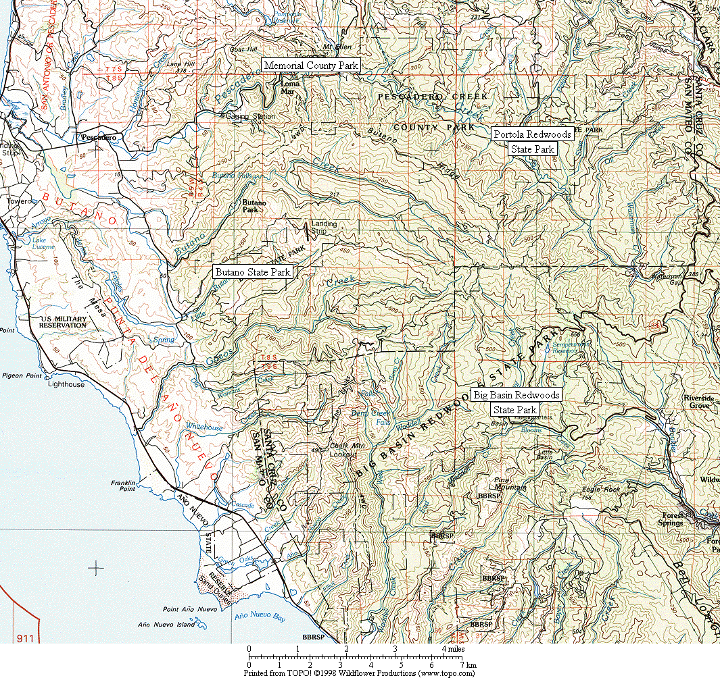

Figure 1. General location of survey areas.

Figure 2. Common Ravens have increased dramatically in all six Christmas Bird Count circles in the Santa Cruz Mountains region. (Note: data presented as a 3-year running mean.)

Figure 3. Increase in Common Raven as recorded by all six Santa Cruz Mountains region CBCs combined. (See Figure 2 for listing of individual counts.)
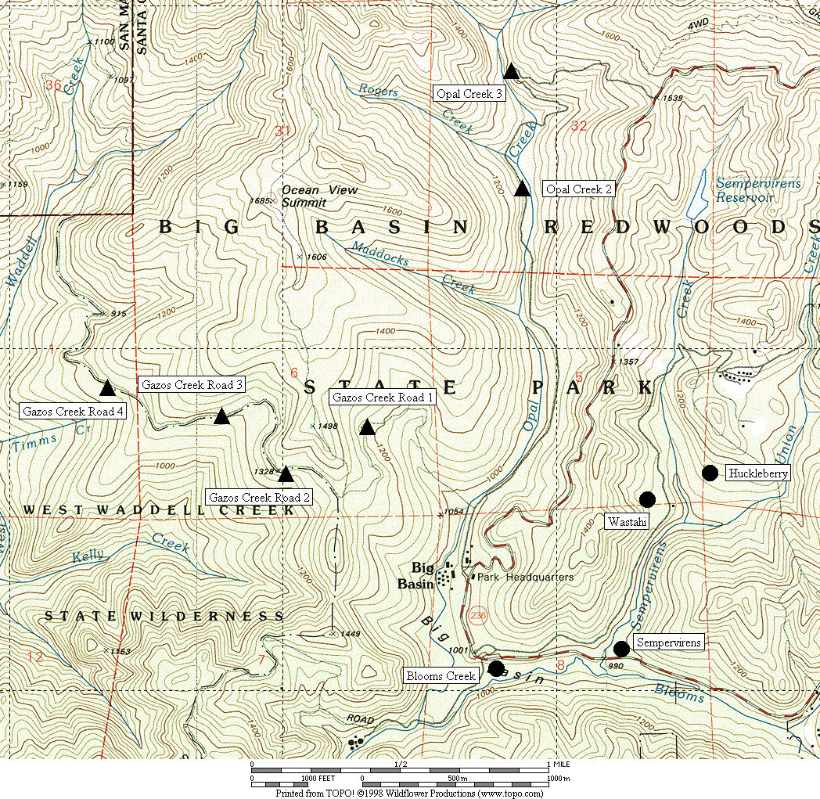

Figure 4. General location of corvid surveys area at Big Basin Redwoods State Park.
● treatment sites ▲ control sites

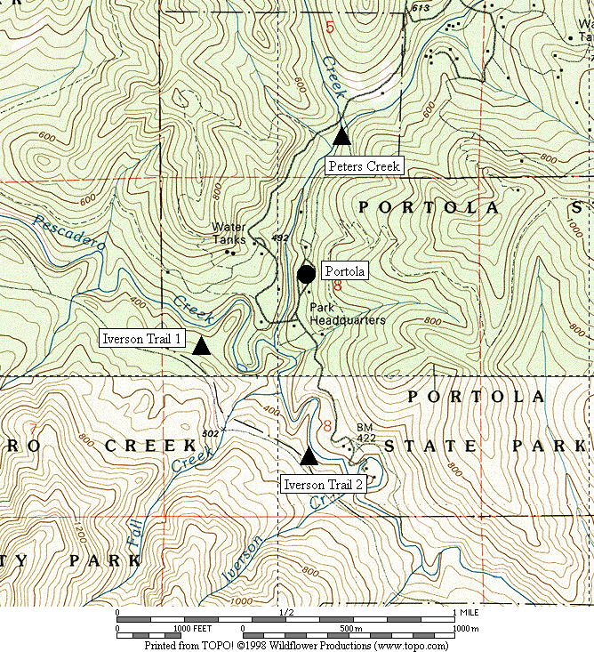

Figure 5. General location of corvid surveys area at Portola Redwoods State Park.
● treatment sites ▲ control sites

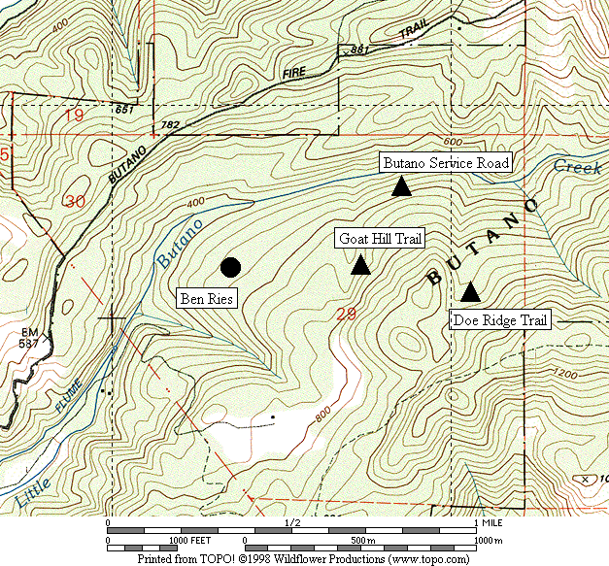

Figure 6. General location of corvid surveys area at Butano State Park.
● treatment sites ▲ control sites

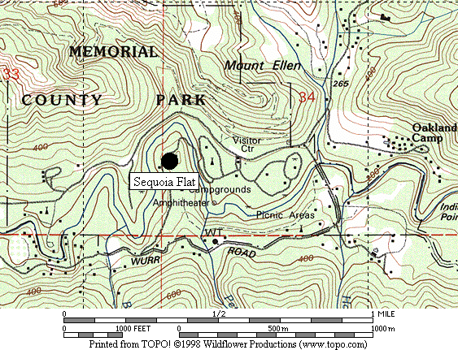

Figure 7. General location of corvid surveys area at San Mateo County Memorial Park.
● treatment site

Figure 8. Abundance of Steller’s Jay at all sites combined from 2002 to 2006.

A. Big Basin B. Portola

C. Butano D. Memorial

Figure 9. Abundance of Steller’s Jay in each park from 2003 to 2006.

Figure 10. Relative abundance of Steller’s Jays in treatment areas in each park from 2003-2006.

Figure 11. Abundance of Common Raven at all sites combined from 2002 to 2006.

A. Big Basin B. Portola
(Note: no ravens recorded in control
areas at Portola in 2005 and 2006)

C. Butano D. Memorial

Figure 12. Abundance of Common Raven in each park from 2003 to 2006.

Figure 13. Relative abundance of Common Raven in treatment areas in each park from 2003-2006.

Appendix 1. Raw numbers of Steller’s Jays and Common Ravens on each survey, 2003-2006.

STELLER’S JAY

Survey Area 2003 2004 2005 2006
Run 1 2 3 4 Run 1 2 3 4 Run 1 2 3 4 Run 1 2 3 4

Big Basin
Blooms 25 47 57 93 27 18 47 36 22 48 43 53 18 44 68 85
Sempervirens 11 25 33 54 17 19 18 25 11 19 14 19 5 13 28 9
Huckleberry 41 45 48 102 48 39 23 32 27 26 39 37 12 34 41 58
Wastahi 10 2 4 23 4 10 15 16 2 5 4 6 2 8 7 5
Opal 2 3 3 2 1 0 2 1 3 1 1 0 2 0 2 1 2
Opal 3 4 0 2 0 1 4 2 2 0 2 0 0 0 0 0 0
Gazos 1 4 4 3 1 2 2 1 1 1 3 0 0 2 4 2 2
Gazos 2 0 2 2 1 1 1 0 1 3 0 0 0 0 1 1 2
Gazos 3 1 4 3 0 2 0 2 2 0 2 0 0 1 2 2 2
Gazos 4 3 2 2 3 1 1 0 0 0 1 0 1 0 2 1 1

Portola
Portola 7 24 24 37 28 19 20 23 17 16 30 27 17 21 27 21
Peters 3 4 3 3 1 2 0 3 2 0 1 5 1 2 3 2
Iverson 1 8 5 6 6 1 3 2 1 0 4 0 8 2 1 2 1
Iverson 2 3 2 5 2 0 2 3 2 1 0 0 1 3 2 3 1

Butano
Ben Ries 22 32 35 45 18 34 40 46 11 16 43 20 3 15 22 29
Service 4 8 3 4 2 2 5 4 2 2 4 0 4 8 4 6
Goat Hill 4 3 2 3 4 2 2 2 2 4 1 3 1 5 3 3
Doe Ridge 6 12 5 5 11 7 7 4 7 5 1 2 2 5 4 3

Memorial
Sequoia 46 71 107 179 46 79 136 133 36 76 161 142 25 42 48 93

Appendix 1, continued.

COMMON RAVEN

Survey Area 2003 2004 2005 2006
Run 1 2 3 4 Run 1 2 3 4 Run 1 2 3 4 Run 1 2 3 4

Big Basin
Blooms 3 3 0 0 2 2 2 2 2 0 0 2 1 2 0 2
Sempervirens 1 0 0 0 1 0 4 4 1 0 0 0 0 1 0 0
Huckleberry 3 3 3 3 2 3 2 4 2 2 5 1 3 5 4 1
Wastahi 0 0 0 0 1 1 1 1 1 3 2 0 0 1 1 0
Opal 2 0 0 1 0 1 0 1 1 0 0 0 0 0 0 0 0
Opal 3 0 3 0 0 0 0 0 0 0 0 0 0 2 0 0 1
Gazos 1 0 0 0 0 0 0 0 0 0 1 0 0 0 1 0 1
Gazos 2 0 0 0 0 0 0 0 0 0 0 0 0 0 0 0 0
Gazos 3 0 1 1 0 0 1 0 0 0 0 0 0 0 0 0 0
Gazos 4 0 0 0 0 0 0 0 0 0 0 0 0 0 0 0 0

Portola
Portola 0 4 3 3 1 5 4 2 1 0 0 0 2 2 3 1
Peters 0 1 0 0 0 0 0 0 0 0 0 0 0 0 0 0
Iverson 1 0 0 1 0 1 0 0 0 0 0 0 0 0 0 0 0
Iverson 2 0 0 0 0 0 0 0 0 0 0 0 0 0 0 0 0

Butano
Ben Ries 1 0 0 1 2 1 6 7 1 0 0 0 2 2 1 2
Service 1 1 0 1 0 0 0 0 0 0 0 0 0 0 0 0
Goat Hill 0 0 0 0 0 0 0 0 0 0 0 0 1 0 0 0
Doe Ridge 0 0 0 0 1 1 0 0 0 1 0 0 0 0 0 0

Memorial
Sequoia 2 3 4 5 7 5 7 5 5 5 9 2 2 3 0 0

